**Shettihalli Rosary Church in Hassan – Karnataka**

**Shettihalli Church** (referred to as **Sathalli** in colonial documents) is located 2km from [Shettihalli, Hassan](https://en.wikipedia.org/wiki/Hassan_district" \o "Hassan district), in [Karnataka](https://en.wikipedia.org/wiki/Karnataka). Built in the 1860s by the French missionaries in [India](https://en.wikipedia.org/wiki/India), the church is a magnificent structure of [Gothic Architecture](https://en.wikipedia.org/wiki/Gothic_Revival).[\](https://en.wikipedia.org/wiki/Shettihalli_Rosary_Church#cite_note-1) After the construction of the [Hemavati Dam and Reservoir](https://en.wikipedia.org/wiki/Hemavati_River" \o "Hemavati River) in 1960 the church was abandoned.[]](https://en.wikipedia.org/wiki/Shettihalli_Rosary_Church#cite_note-Church-2) It has since then become a famous tourist spot where people flock to see the half submerged church during monsoon. It is also known as *The Submerged Church* and *The Floating Church*.

History:

The Church was built in 1860 by the French missionaries for the wealthy British estate owners. In 1960 the construction of the Hemavati Dam and Reservoir led to the abandonment of the church. Since then the church submerges in water every year during monsoon season. It attracts a lot of tourists who visit the ruins to see this spectacular sight.

To enjoy the surreal beauty of Shettihalli church,[[4]](https://en.wikipedia.org/wiki/Shettihalli_Rosary_Church#cite_note-AncientChurch-4) one needs to travel to this place twice. Once in the month of July–October when it is partially submerged in water and next in the month of Dec–May when the water level recedes and the church grounds emerge.

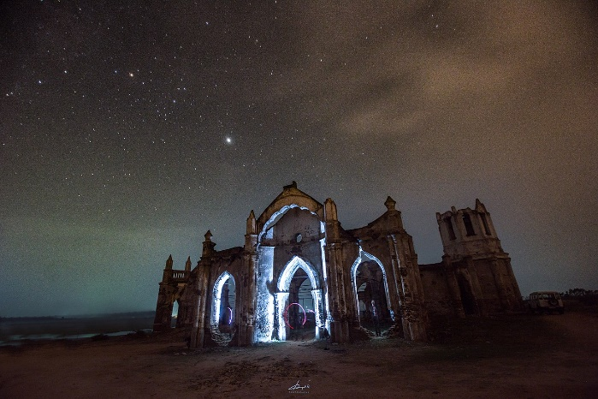

1st photo:

<https://en.wikipedia.org/wiki/Shettihalli_Rosary_Church#/media/File:Shettihalli_Rosary_Church_in_night_sky.jpg>

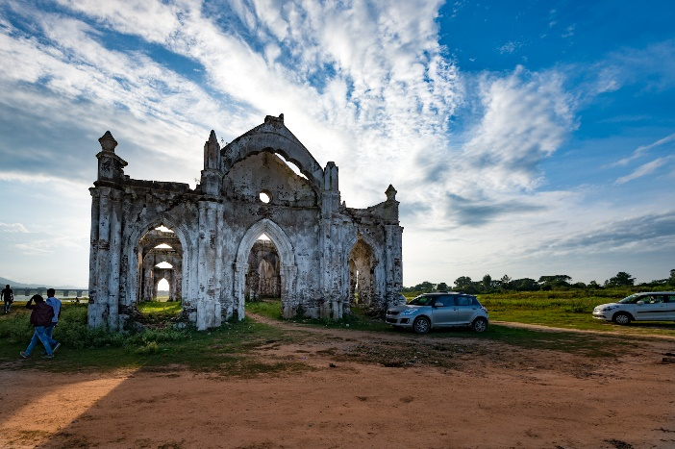

2nd photo:

<https://www.google.com/search?q=Shettihalli+Rosary+Church+in+Hassan+%E2%80%93+Karnataka&rlz=1C1CHBD_enIN932IN932&sxsrf=AOaemvKyJiaC1rk2EyJGQ3UOWEPLP1Fexg:1633002758840&source=lnms&tbm=isch&sa=X&ved=2ahUKEwjkxe2q0abzAhWu4jgGHQ81AyAQ_AUoAXoECAEQAw&cshid=1633002802844989&biw=1536&bih=696&dpr=1.25#imgrc=7lYI7g7xOyTSbM>

Vlog:

<https://youtu.be/fa0pPRe1Cwc>